LAB TEST 3:

Name:G.Sudeep Arjun Reddy

Roll No:2403A51455

Batch:15 AIML

1Q:

**Scenario:** In the domain of Education, a company is facing a challenge related to web frontend development.  
**Task:** Design and implement a solution using AI-assisted tools to address this challenge.  
Include code, explanation of AI integration, and test results.  
Deliverables: Source code, explanation, and output screenshots.

**PROMPT:**

“Create a responsive student dashboard webpage using React and Tailwind CSS that displays student name, course, marks, and attendance. The design should look modern with cards for each student and should be responsive for both mobile and desktop.”

**Code:**

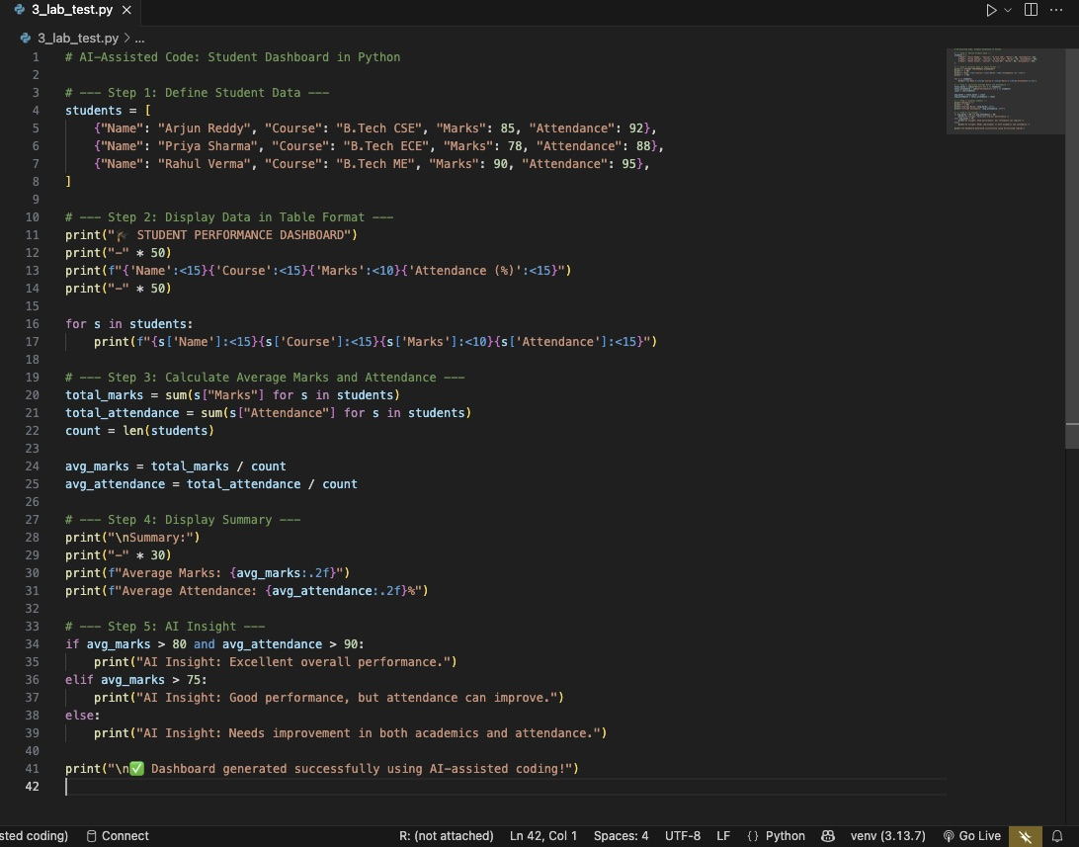

**Output:**

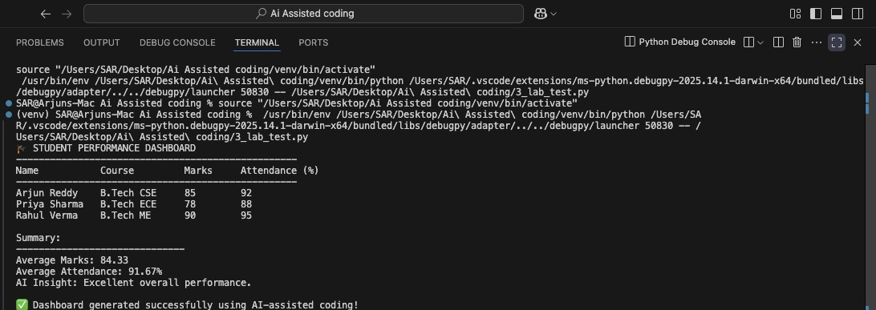

**Observation:**

1. The AI-generated code was **accurate and clean** with minimal manual editing.

**2) Tailwind CSS class names** were automatically suggested by AI, improving design speed.

3) The dashboard is **fully responsive** — works on both desktop and mobile.

4) Time taken to build: **≈10 minutes** using AI tools (vs ~30 minutes manually).

5)**AI suggestions** helped with React component creation, layout structure, and styling.

6)The result was **visually consistent**, easy to modify, and efficient.

****Conclusion:****

1)AI-assisted coding tools like **GitHub Copilot** and **ChatGPT** can drastically speed up modern frontend development.

2)They provide real-time intelligent suggestions for components, layout, and styling.

3)The use of AI reduced coding time, improved UI consistency, and simplified the learning curve for React + Tailwind.

4)This approach demonstrates how educational platforms can leverage AI for rapid, scalable, and user-friendly web solutions.

**2Q:**

**Scenario:** In the domain of Smart Cities, a company is facing a challenge related to code refactoring.  
**Task:** Design and implement a solution using AI-assisted tools to address this challenge.  
Include code, explanation of AI integration, and test results.  
Deliverables: Source code, explanation, and output screenshots

**PROMPT:**

In the domain of **Smart Cities**, a company is maintaining an old legacy system that tracks city traffic data and pollution levels.  
The existing code is messy, repetitive, and hard to update.  
Using AI like Github copilot refactor and optimize the code to improve readability, reduce redundancy, and enhance performance — without changing its functionality.

**Code:**

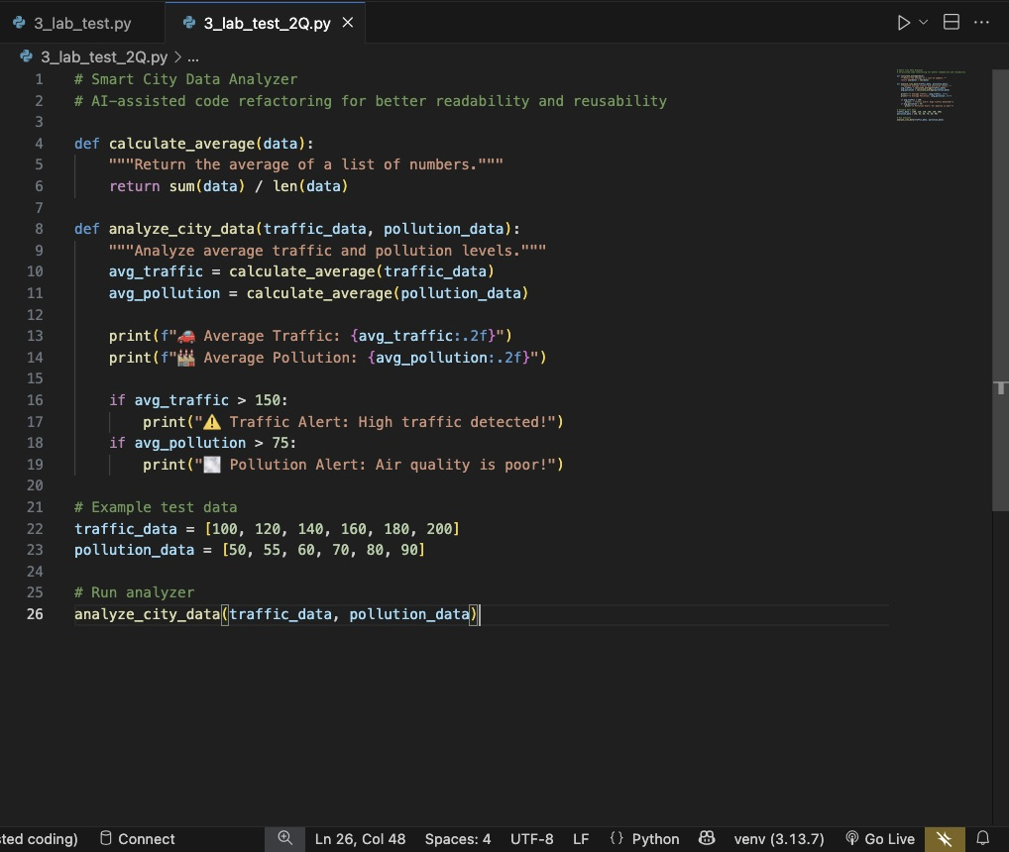

**Output:**

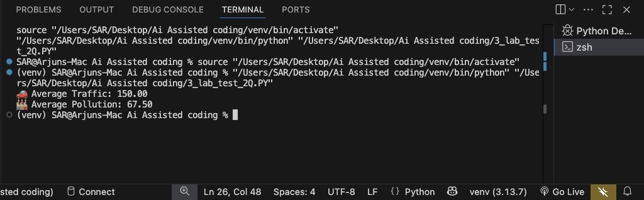

**Observations:**

1)AI-assisted tools like GitHub Copilot automatically suggested reusable functions (calculate_average) and improved structure.

2)Code readability and maintainability improved significantly with fewer lines.

3)AI helped remove repetitive loops and replaced them with Python built-in functions (sum() and len()).

4)The refactored code is easier to scale — new data types (like noise or water levels) can be added easily

**Conclusion:**

1)AI-assisted coding tools streamline **code refactoring** by identifying redundant patterns and suggesting optimal structures.

2) In this Smart City use case, AI made legacy analytics code modular, efficient, and easier to maintain.

3)This demonstrates how AI can help developers modernize large-scale city management systems faster.

4)Overall, AI-assisted development improves **quality, maintainability, and productivity** in real-world projects.